**Exercise2: Dealing with slow and unavailable connections:**

Fix the Users Component: Test with refresh!!

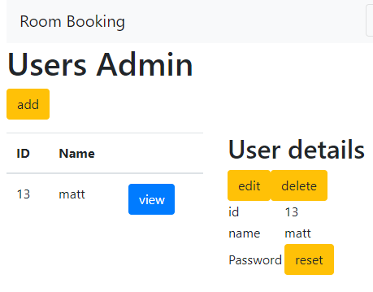

Create 2 methods, put only the loadData() in the ngOnInit() and use the same fields

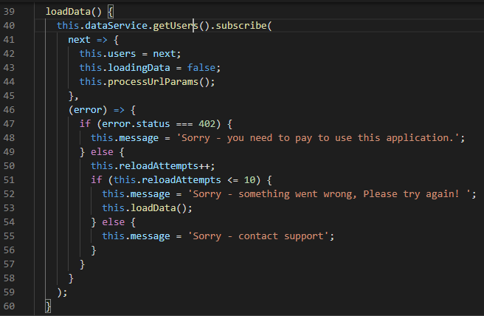

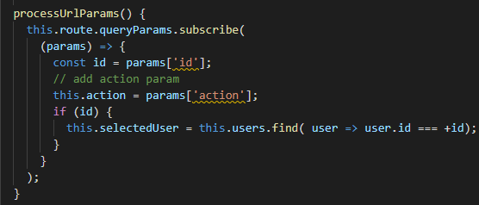

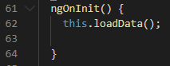

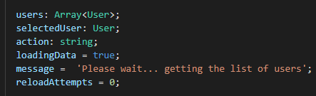

Message output for the User html page

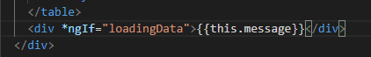

Add the delay in the server code:

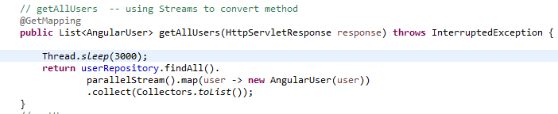

Test with serve on and off and this works!!